Python inbuilt functions

print() -

input() - read data from user(default string type)

type() - return the datatype

id() - return the address of object

min()

max()

len() - return the size of seqence(list,tuple,set,)

------------------

int()

float()

Str()

complex()

bool()

list()

set()

tuple()

dict()

bytes()

bytearray()

frozenset()

range()

nonetype()

--------------------

int() - function

can be represent using

decimal format : 0-9

binary format : 0,1

octal format : 0-7

hexadecimal format : 0-9,a,b,c,d,e,f/A,B,C,D,E,F

a = 15

print(bin(a))

print(oct(a))

print(hex(a))

----------------------

float()

complex datatype

10+20j

0+oj = 0

---------------------

mutable vs Immuatable

a = 100

a = 200

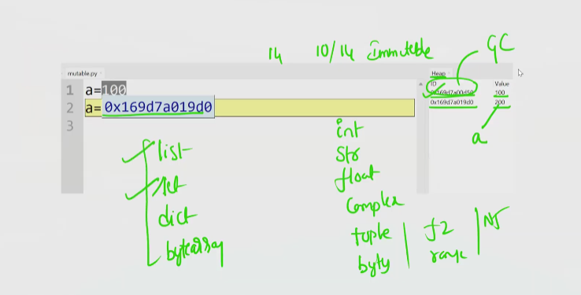

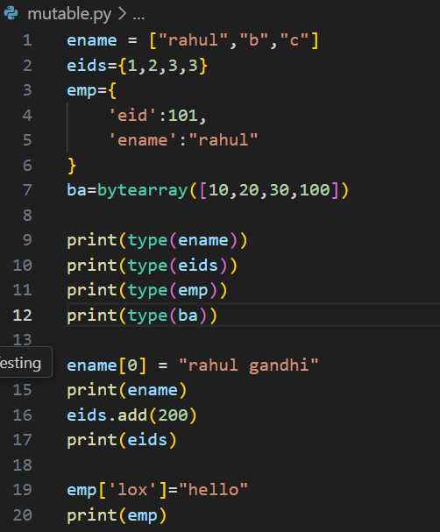

out of 14 datatypes 10 are Immuatable

List

Set

Dict

Bytearray

These are mutable datatypes

Bytearray vs bytes

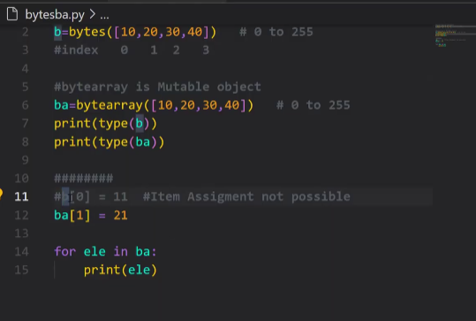

Python error

